LUA
COMPUTER
SCIENCE
by
Christopher Andrew Topalian

All Rights Reserved
Copyright 2000-2024
Dedicated
to
God the Father

Download Lua
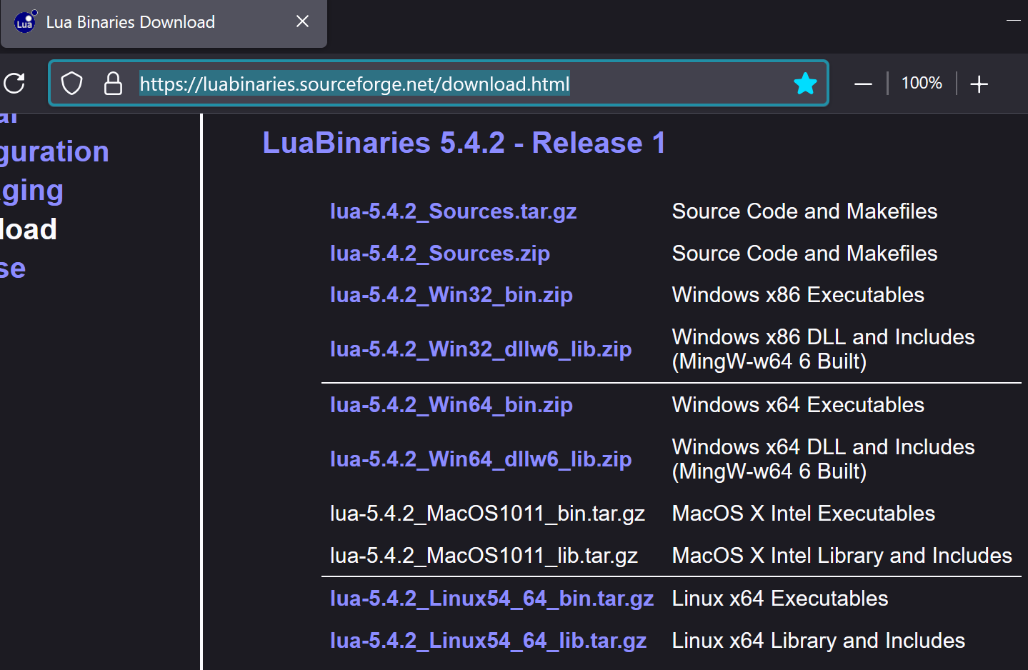
We Download Lua from:
https://luabinaries.sourceforge.net/download.html

On Windows: Download the file named:
lua-5.4.2_Win64_bin.zip
Windows x64 Executables

On Mac: Download the File named:
lua-5.4.2_MacOS1011_bin.tar.gz
MacOS X Intel Executables

On Linux: Download the File named:
lua-5.4.2_Linux54_64_bin.tar.gz
Linux x64 Executables

Extract the LUA zip file
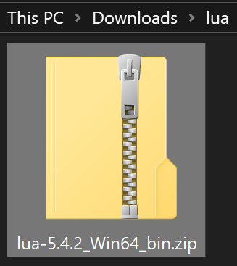

Right Click on the Downloaded Zip Folder
Choose Extract All...
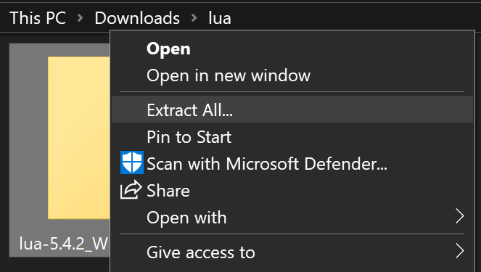

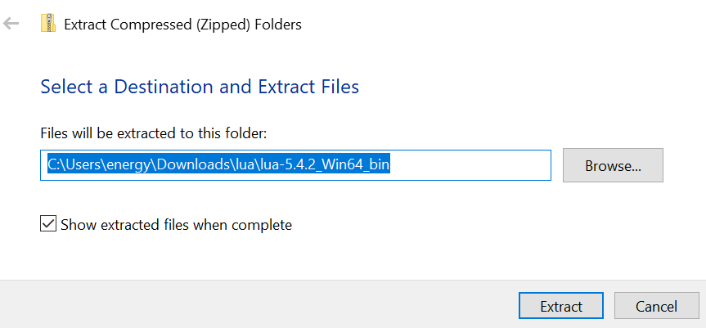
Left Click Extract Button

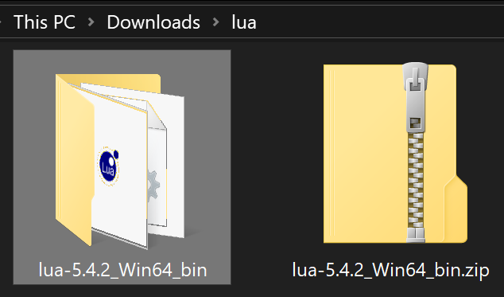
Here is our Lua Folder. Now that it is extracted we can use the .exe files in the Lua Folder.
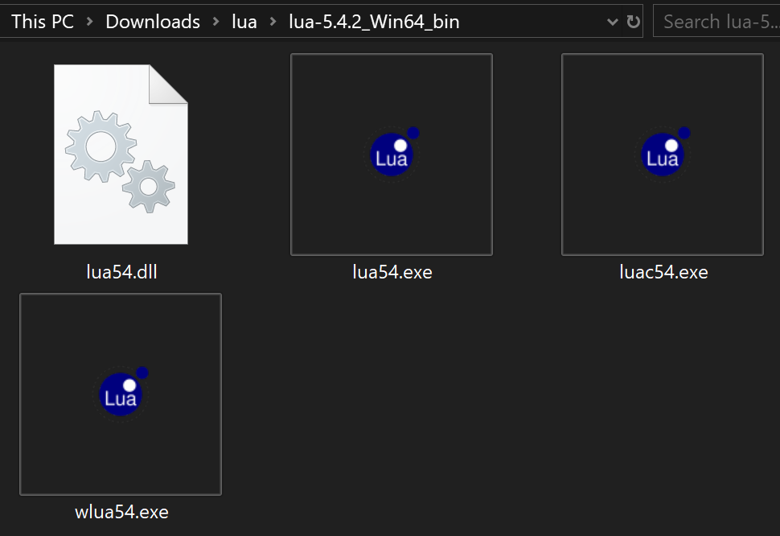

Above, we see our Lua Folder.
This Lua Folder contains the Lua .exe files.
Currently, they are named with a version number, such as, Lua54.exe

But, since we don't want to have to write the version number everytime that we cmd,
we can change the name of these files to say lua without the version number of 54.
Thus, as shown on the next page, let us change the names of these files to say only lua
lua54.exe will be renamed to lua.exe
We change the names of the Lua .exe files,
to make it easier for us to use cmd later
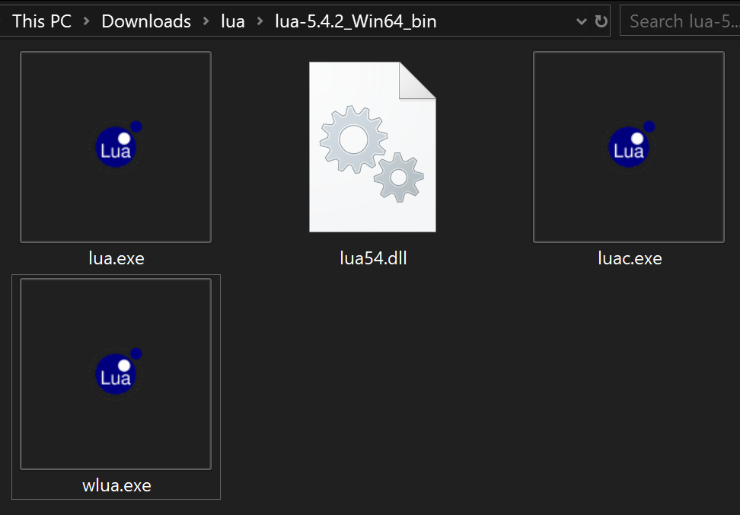

As we can see above, the Lua .exe files are now named without a version number.
We have changed the name of the exe files to make it easier for us to later cmd our folder and thus to activate our scripts we now only have to write in command prompt:
lua nameOfScript.lua
instead of
lua54 nameOfScript.lua
We Copy the Path of our Lua Folder to later use it for our Lua Environment Variable
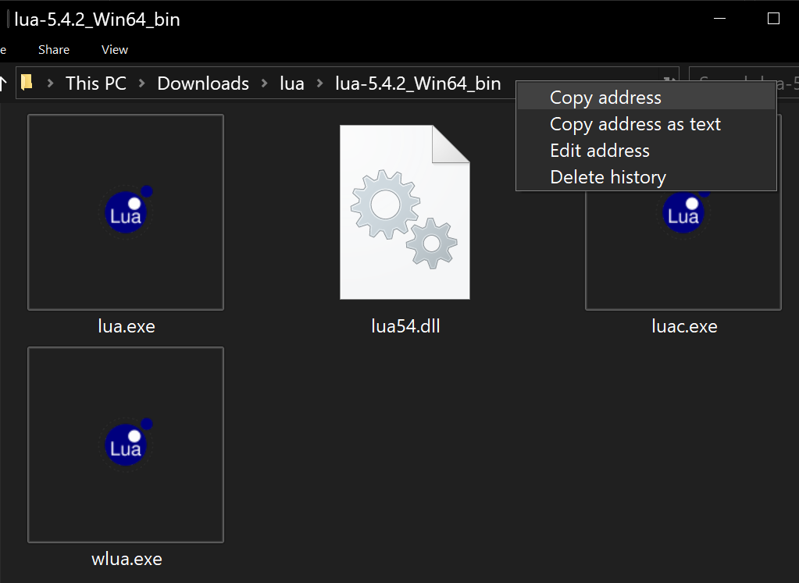

We have copied the Path of our Lua folder.
It looks like this:
C:\Users\energy\Downloads\lua\lua-5.4.2_Win64_bin

We will later use this path, to add a Lua Environment Variable on Windows, so that we can cmd our scripts and have them open in Command Prompt.
We Add an Environment Variable for Lua
for cmd Ability
In the Windows Start Menu SEARCH for:
environment
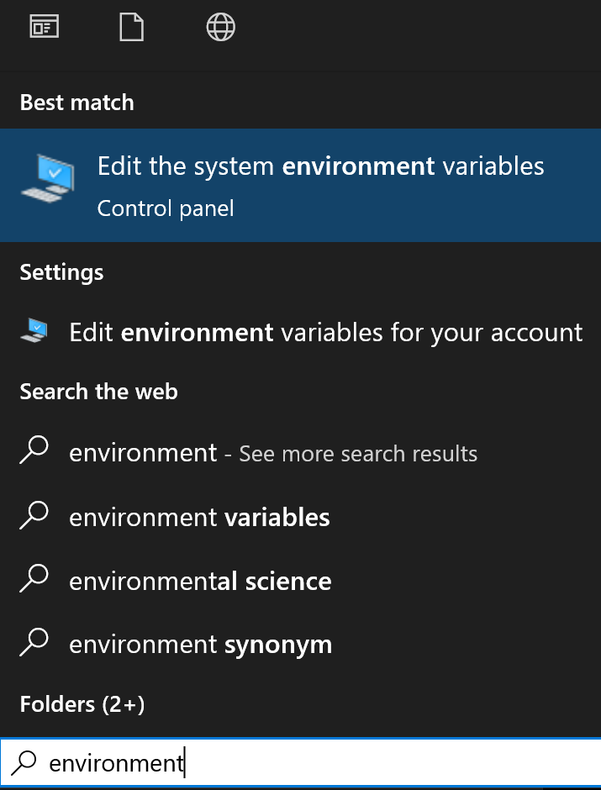

We Left Click on:
Edit the system environment variables
System Properties Opens and we
Left Click on Environment Variables Button
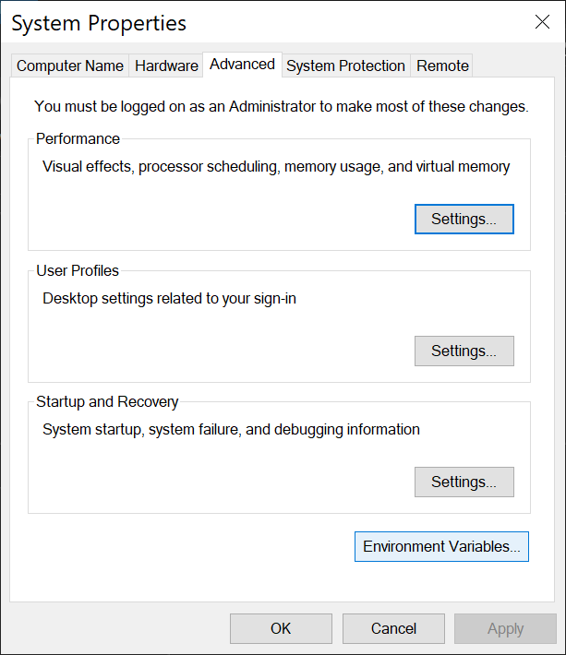
-

We Left Click on:
Environment Variables... Button
In System Variables, at the bottom, we Left Click on Path, and then Left Click Edit Button
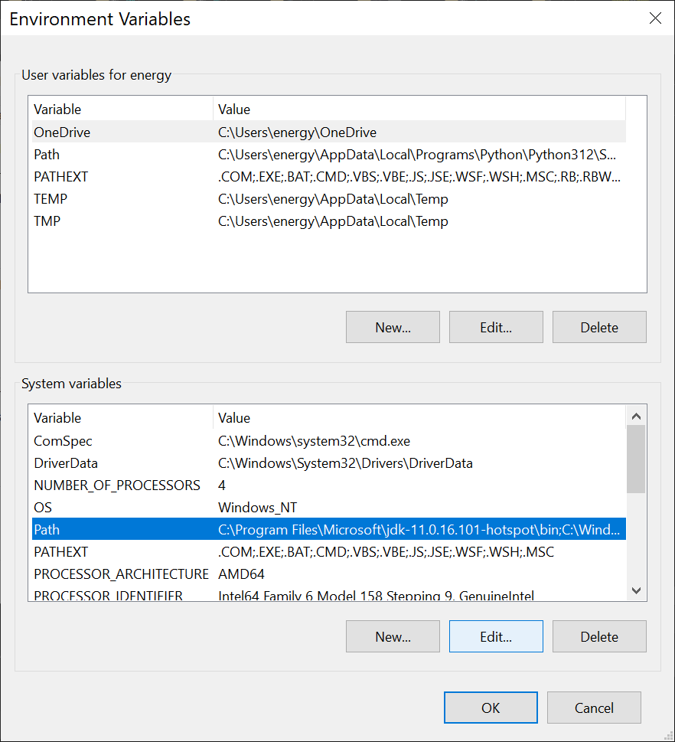

We Left Click on:
Path

We Left Click on:
Edit Button
We make a New Environment Variable and paste the address of our Lua Folder
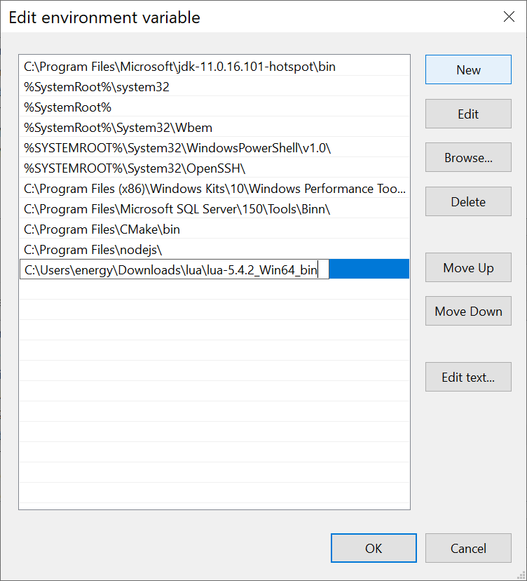

We Left Click on:
New Button
We Paste the Lua Folder Address:
Control + V or Right Click Paste

C:\Users\energy\Downloads\lua\lua-5.4.2_Win64_bin

We Left Click on:
OK Button
We Left Click the OK Button of the Environment Variables to Confirm the Changes that we have made
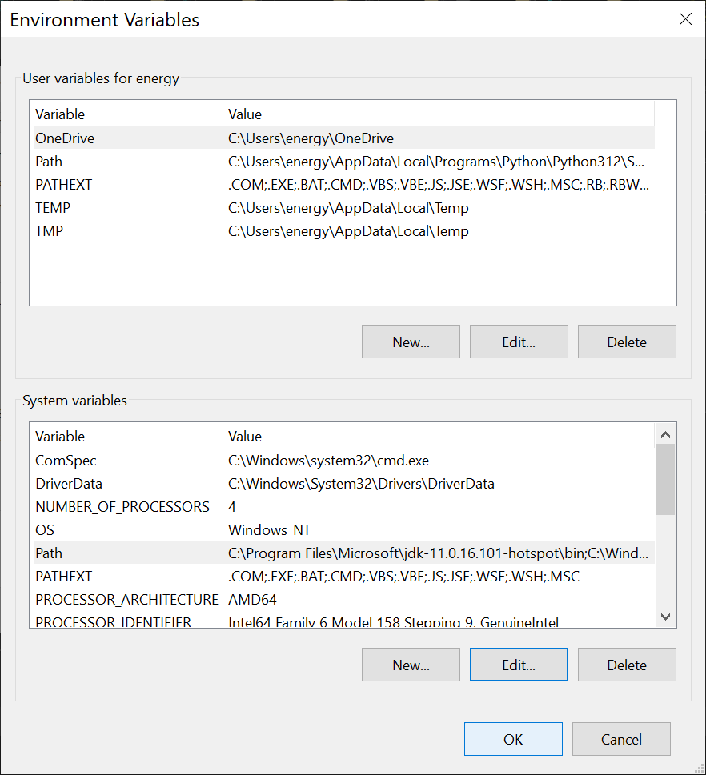

We Left Click on:
OK Button

We Left Click the OK Button of the System Properties to Confirm the Changes that we have made

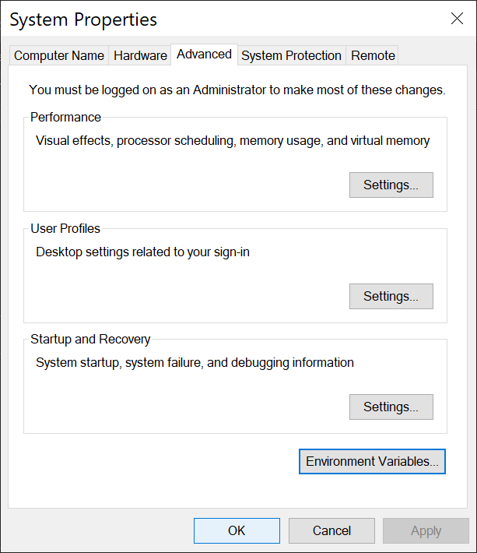

Now we can use Lua Scripts on our Computer.

Happy Scripting :-)
In VSCode Editor we Make a New File and Type the our First Lua Script and Save it as print.lua
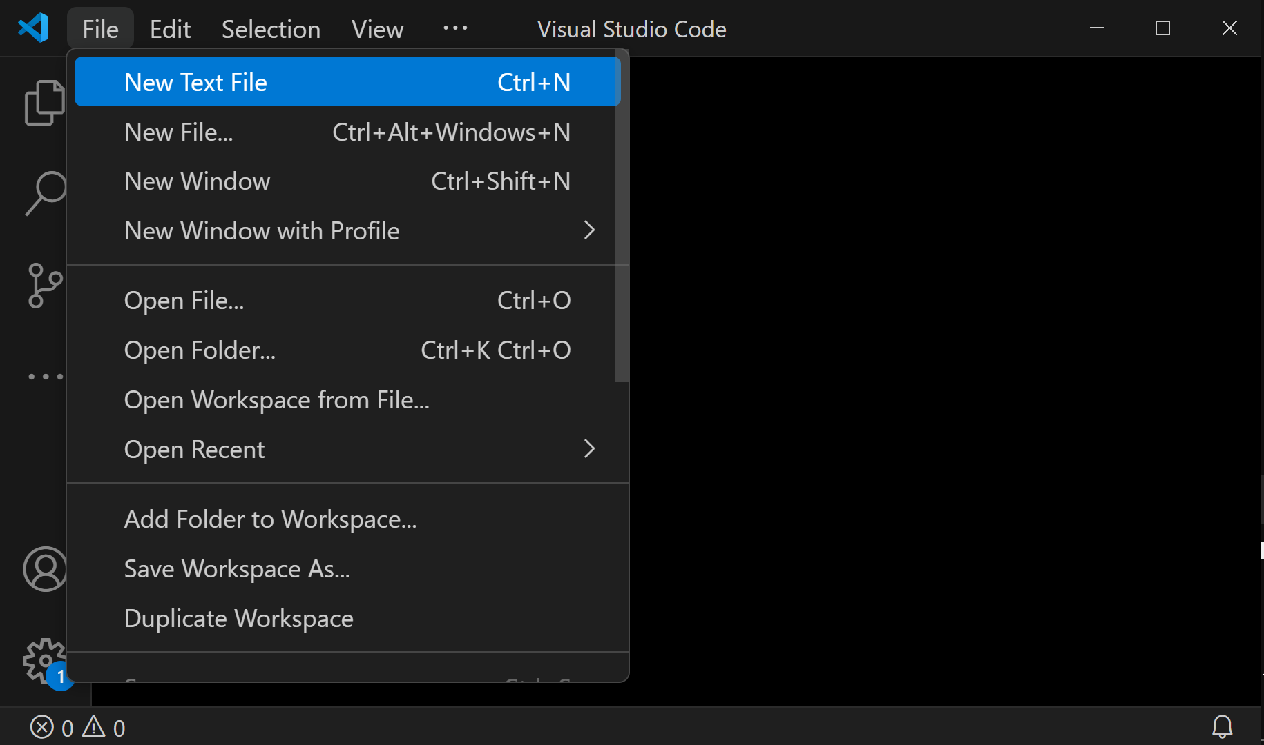
VSCode will color the code what we type in Lua.

SEE NEXT PAGE for CODE: print.lua
-- print.lua

print("Hi Everyone")

io.write("Press Enter to Exit")

io.read()

----

-- Hi Everyone
-- Press Enter to Exit

We Save our Lua Script as print.lua
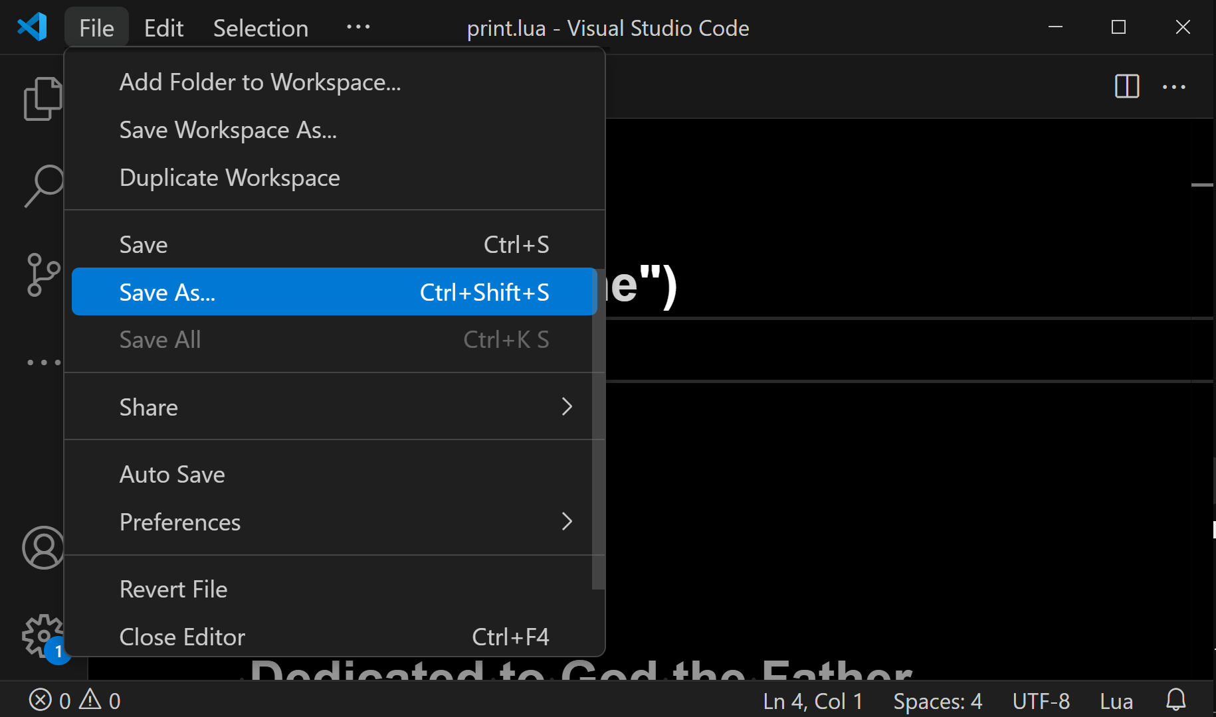
We Left Click:
Save As...

We Make a New Folder Named:
ourFirstProject

Next page shows our first lua script that we saved in ourFirstProject folder.

We Left Click the Save Button to Save our
Lua script in ourFirstProject Folder
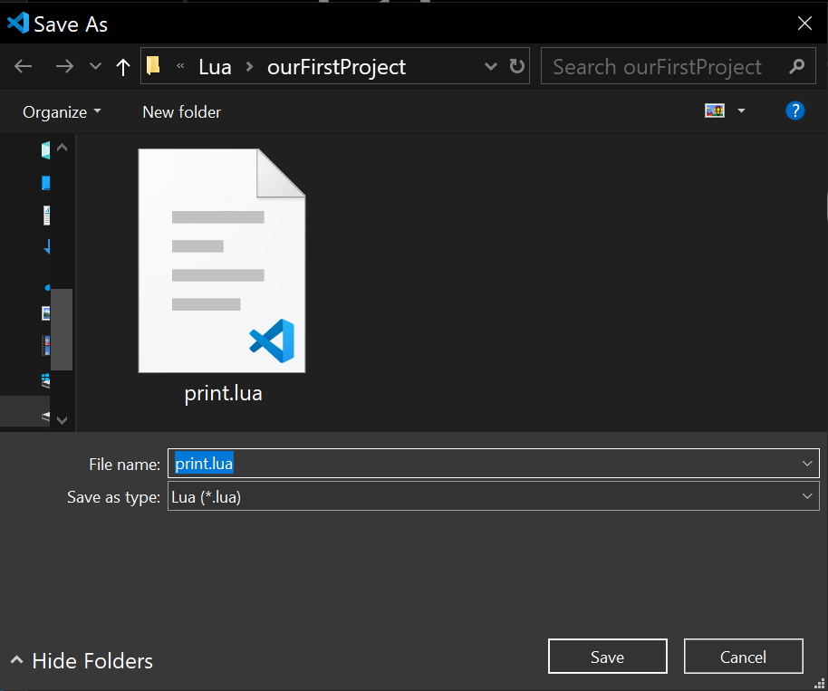

On the next page, we show a very easy way to locate the script that we have Saved in VSCode, so that we can run it.

In VSCode, We Right Click on the Tab for print.lua file and Choose Reveal in File Explorer
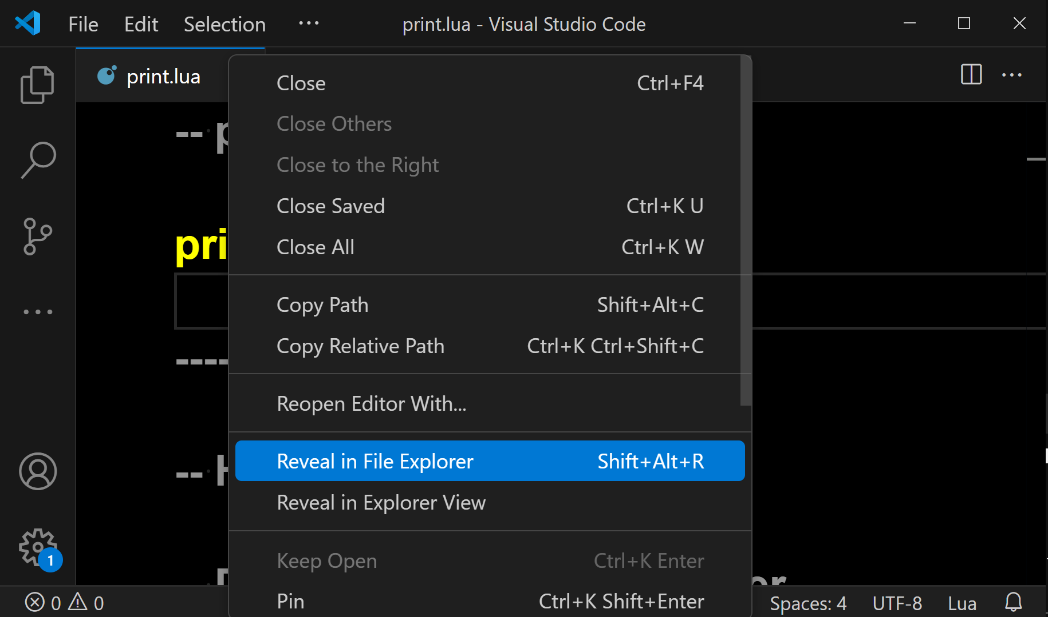

We Right Click:
print.lua Tab

We Left Click:
Reveal in File Explorer

We see our Lua script, named print.lua, which we placed in a folder that we named ourFirstProject
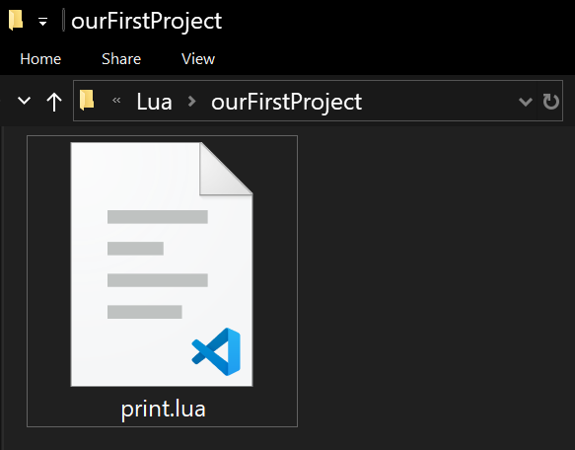

We Left Click:
Address Bar of ourFirstProject folder

From Left Clicking in the Address Bar of ourFirstProject folder, we see that it is now highlighted
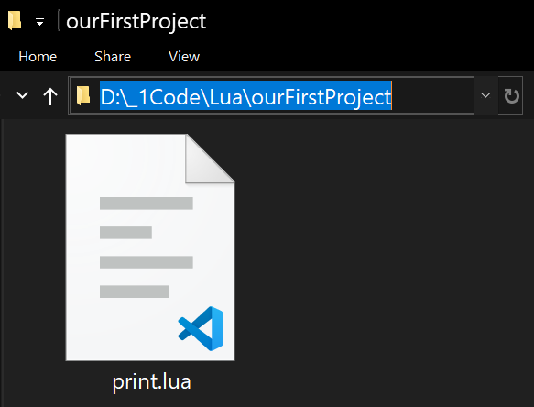

Now that we have the Address Bar Highlighted, meaning, selected,
we can type what is shown on the next page in this address bar and then hit the Enter button on the keyboard.
Typing cmd in Address Bar of Folder
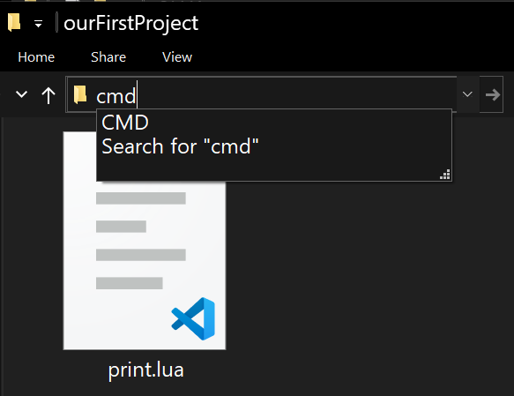

We Type:
cmd
press Enter
We See the Command Prompt has opened in ourFirstProject folder
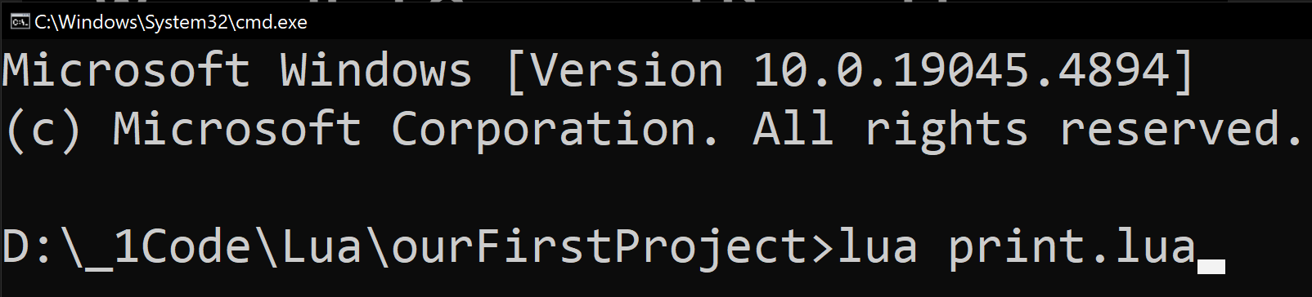
We Type:
lua print.lua
press Enter
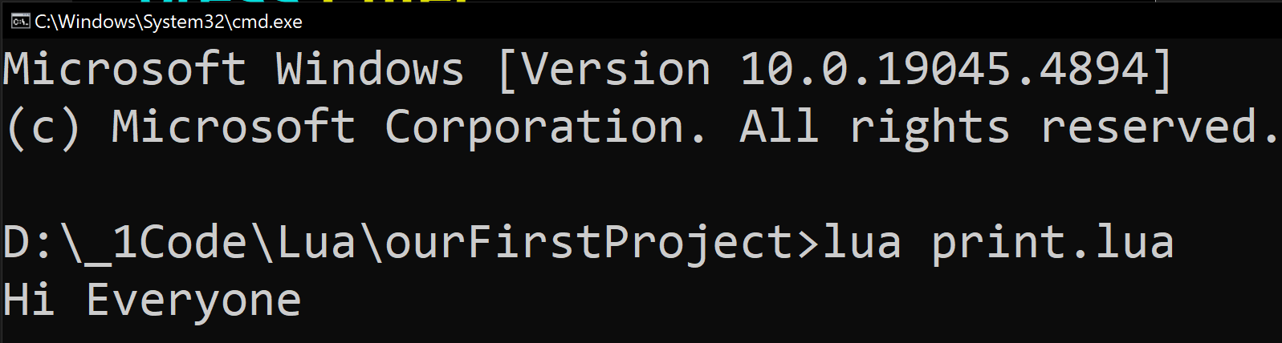
Result of activating our Code:
Hi Everyone

-- print_comments.lua

print("Hi Everyone")

io.write("Press Enter to Exit")
io.read()

-- This is a single line comment in Lua

--[[
This is a multi line comment in Lua

We write our comments freely here
]]--

----

-- Hi Everyone
-- Press Enter to Exit

-- print_with_multiple_line_breaks.lua

print("Hi Everyone\n\nHappy Scripting")

io.write("Press Enter to Exit")
io.read()

----

--[[
Hi Everyone

Happy Scripting
Press Enter to Exit
--]]

-- print_variable_integer.lua

local ourInteger = 25

print(ourInteger)

io.write("Press Enter to Exit")
io.read()

-- 25
-- Press Enter to Exit
-- print_variable_string.lua

numberOfPeople = "Twenty"

print(numberOfPeople)

io.write("Press Enter to Exit")
io.read()

----

--[[
Twenty
Press Enter to Exit
--]]

-- open_browser.lua

local url = "https://www.x.com"

io.popen('start "" "' .. url .. '"')

print(url .. " is opened")

io.write("Press Enter to Exit")
io.read()

----

--[[
https://www.google.com is opened
Press Enter to Exit
]]--

-- open_a_file_in_write_mode.lua

local file = io.open("001.txt", "w")

-- write content to the file
file:write("Hi Everyone\n")
file:write("Here is more text")

-- close file to save changes
file:close()

io.write("Press Enter to Exit")
io.read()
-- read_text_file.lua

local file = io.open("001.txt", "r")

-- check if file was opened
if file then
-- read each line of file
for line in file:lines() do
print(line)
end
-- close file after reading
file:close()
else
print("File did not open")
end

io.write("Press Enter to Exit")
io.read()
-- tables_key_value_pairs.lua

local people = {
{
name = "jane",
score = 98
},
{
name = "tabitha",
score = 98
}
}

for i = 1, #people do
print("Name: " .. people[i].name .. ", Score: " .. people[i].score)
end

io.write("Press Enter to Exit")
io.read()

--[[
Name: jane, Score: 98
Name: tabitha, Score: 98
Press Enter to Exit
]]--

-- isNumberEvenOrOdd.lua

-- checks if a number is even or odd
function checkEvenOdd(number)
if number % 2 == 0 then
print(number .. " is even.")
else
print(number .. " is odd.")
end
end

-- ask user to input a number
print("Enter a number to check if it's even or odd:")

-- read user input (string) and convert it to a number
local input = io.read("*n")

-- check if input is a valid number
if input then
checkEvenOdd(input)
else
print("Use a valid number")
end

print("Press Enter to exit.")
io.read()

----

--[[
Enter a number to check if it's even or odd:
25
25 is odd.
Press Enter to exit.
]]--

True Artificial Intelligence System
Tautology
1111
Contra-
-diction
0000
XOR
0110
XNOR
1001
AND
0001
NAND
1110
OR
0111
NOR
1000
MI
1101
MNI
0010
LP
0011
LC
1100
RP
0101
RC
1010
CI
1011
CNI
0100
16-Gon
For More Tutorials:

GitHub.com/ChristopherTopalian
GitHub.com/ChristopherAndrewTopalian
Sites.google.com/view/CollegeOfScripting
CollegeOfScripting.weebly.com
CollegeOfScripting.wordpress.com
Youtube.com/ScriptingCollege
Twitter.com/CollegeOfScript
Rumble.com/user/CollegeOfScripting

Dedicated to God the Father

This book is created by the
College of Scripting Music & Science.
Always remember, that each time you write a script with a pencil and paper, it becomes imprinted so deeply in memory that the material and methods are learned extremely well.

When you Type the scripts, the same is true. The more you type and write out the scripts by keyboard or pencil and paper, the more you will learn programming!

Write and Type every example that you find.
Keep all of your scripts organized.
Every script that you create increases your programming abilities.
SEEING CODE, is one thing,
but WRITING CODE is another.
Write it, Type it, Speak it, See it, Dream it.

CollegeOfScripting.weebly.com

